
AZ852
AX3000 CAT12 4G CPE Router

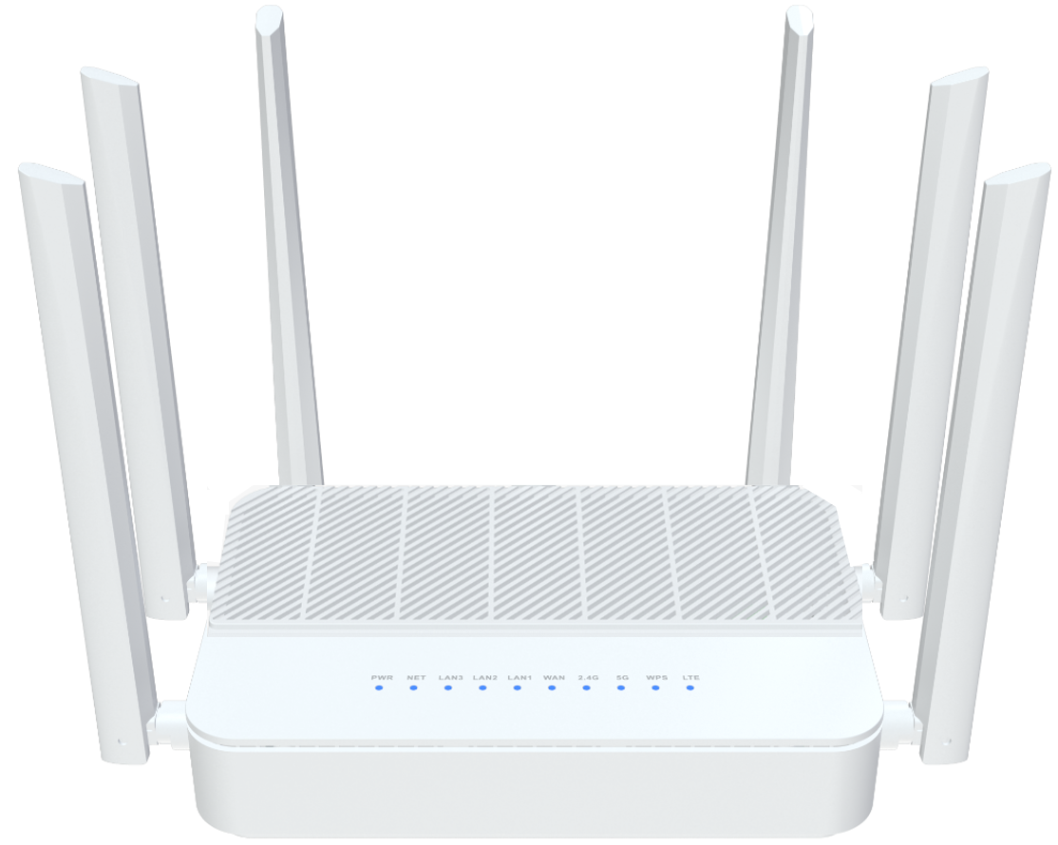
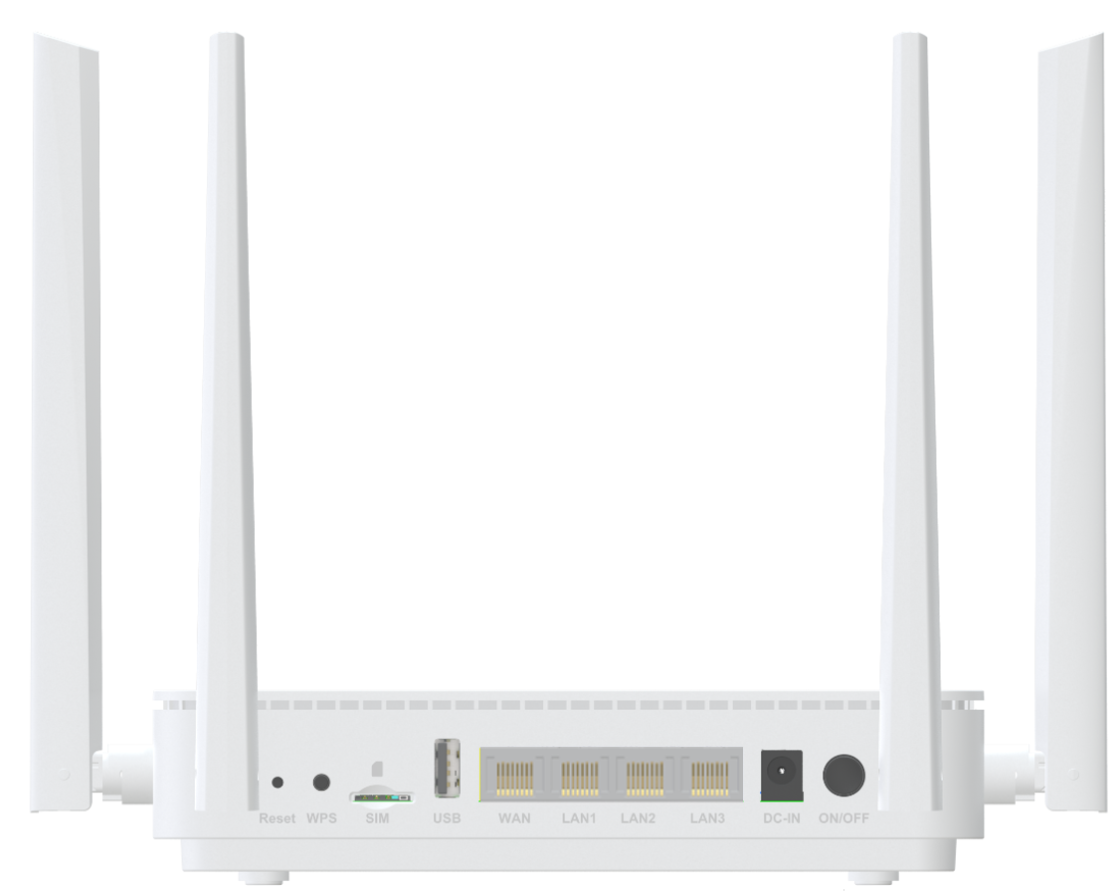

 Descriptions
AZ852 is a dual band concurrent AX3000 CPE with cat12 4G modem, which has been upgraded to the latest 802.11ax
standard technology while maintaining compatibility with IEEE 802.11b/g/n and IEEE 802.11a networks. It’s a SOHO-class
network security solution for family home, broadband communications and small SOHO.

Features
● 1x 10/100/1000BASE-T Ethernet RJ45 WAN Ports;
● 3x 10/100/1000BASE-T Ethernet RJ45 LAN Ports;
● Support 802.11ax 2T2R speed up to 574Mbps;
● Support 802.11ax 2T3R speed up to 2402Mbps;
● Support LTE CAT12 with uplink speed up to 150Mbps, and downlink speed up to 600Mbps;
● Support one USB2.0 ports;


Specifications
AZ852 Specifications
Chip model | MT7981BA +MT7976CN+MT7531AE+CAT12 LTE Moudle(SIM7912E)
Memory | NAND FLASH 1Gbit(128MB)/DDR3 2Gbit（256MB）
WiFi Chip | 2.4G&5G: MT7976CN
Cellular Frequency | LTE-FDD: B1/B3/B5/B7/B8/B20/B28/B32  LTE-TDD: B38/B40/B41/B42/B43/B48  WCDMA: B1/3/5/8
WiFi rate | 2.4G:802.11b/g/n/ax@574Mbps  5G:802.11/a/n/ac/ax@2402Mbps
Interface | WAN: 1* 10/100/1000Mbps auto MDI/MDI-X RJ-45 ports  LAN: 3* 10/100/1000Mbps auto MDI/MDI-X RJ-45 ports  1*nano sim card  1*USB2.0  1*DC JACK
Frequency Band | 2.4 GHz frequency band 40MHz and 5 GHz frequency band 160MHz
Antennas | WIFI : 2*3dBi External dual-band omni antennas  1*3dBi built-in 5G omni antenna  LTE: 4*3dBi External omni antennas
Buttons | WPS，Reset，Power on/off
LED Indicators | Power, NET, LAN3, LAN2, LAN1, WAN, 2.4G,5G, WPS, LTE
Power Supply | DC 12V 2A
Product Size | 180X120X42.2 mm (length X width X height)
Work Environment | Working temperature: 0°C—40°C；  Working humidity: 10—90%
WAN Connection | Support DHCP, PPPoE and Static IP address three internet access models,
Wireless Function | WiFi basic function, WiFi advanced function, Guest network, EASY MESH
Wireless Encryption | WPA/WPA2, WPA2,WPA3
Management Function | WEB/TR069/SSH
System Maintenance | Device management, Configuration management, Upgrade management, Log function, Status statistics, Restart/reset
Advanced Function | Firewall, Virtual server,IPV6, UPnP
Certification | Meet CE certification

