
AZ846
N300 4G CPE Router

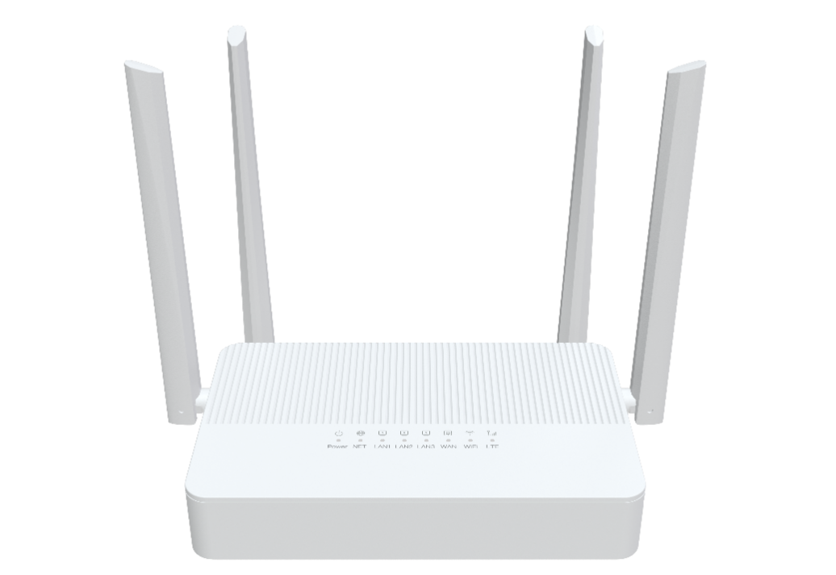

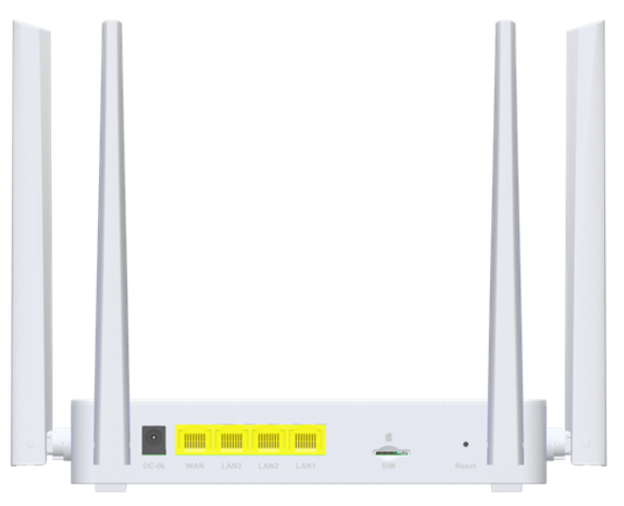
 Descriptions
AZ846 is a N300 CPE with 4G modem, which maintaining compatibility with IEEE 802.11b/g/n networks.
It’s a SOHO-class network security solution for family home, broadband communications and small SOHO.

Features
● 1x 10/100MBASE-T Ethernet RJ45 WAN Ports;
● 3x 10/100MBASE-T Ethernet RJ45 LAN Ports;
● Support Wi-Fi 2.4G 802.11N 2T2R, speed up to 300Mbps;
● Support LTE CAT4 with uplink speed up to 50Mbps, and downlink speed up to 150Mbps;;



Specifications

AZ846 Specifications
Chip model | MT7628NN+CAT4 LTE Moudle
Memory | FLASH 16MB/DDR2 64MB
WiFi Chip | Built in MT7628NN
Cellular Frequency | LTE-FDD: B1/ 3/ 5/7/ 8/20/28  LTE-TDD: B38/40/41  WCDMA: B1/5/8
WiFi rate | 802.11b/g/n Wireless LAN 300Mbps
Interface | LAN: 3* 10/100Mbps auto MDI/MDI-X RJ-45 ports  LAN/WAN: 1* 10/100Mbps auto MDI/MDI-X RJ-45 ports  Sim slot：1*nano sim card
Frequency Band | 2.4 GHz frequency band 40MHz
Antennas | WIFI 2.4G: 2*5dBi External antennas  LTE: 2*3dBi External antennas
Buttons | Reset
LED Indicators | Power NET LAN1 LAN2 LAN3 WAN WIFI LTE
Power Supply | DC 12V 1A
Product Size | 180X110X35 mm (length X width X height)
Work Environment | Working temperature: 0°C—40°C；Working humidity: 10—90%
WAN Connection | Support DHCP, PPPoE and Static IP address three internet access models,
Wireless Function | WiFi basic function, WiFi advanced function, Guest network,
Wireless Encryption | WPA/WPA2, WPA2
Management Function | WEB
System Maintenance | Device management, Configuration management, Upgrade management, Log function, Status statistics, Restart/reset
Advanced Function | Firewall, Virtual server,IPV6, UPnP
Certification | Meet CE certification

