
AZ797M
3GE AC1200 Mesh Router

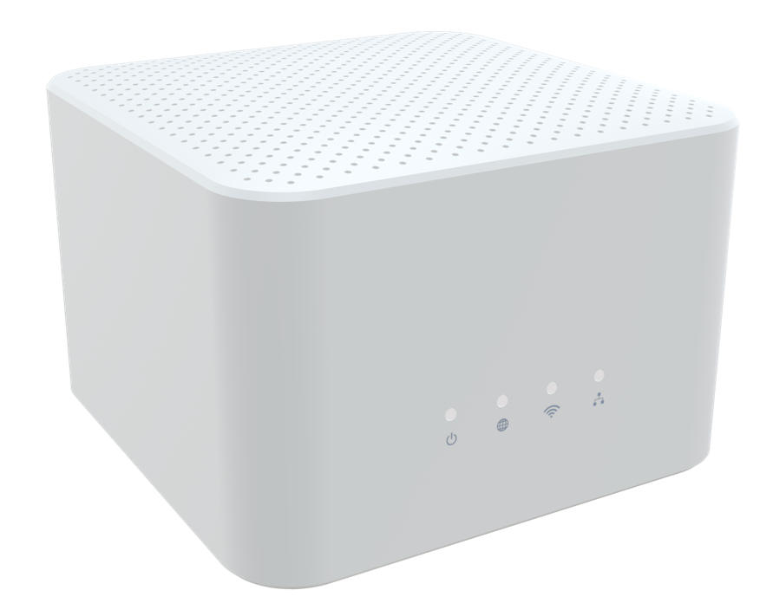
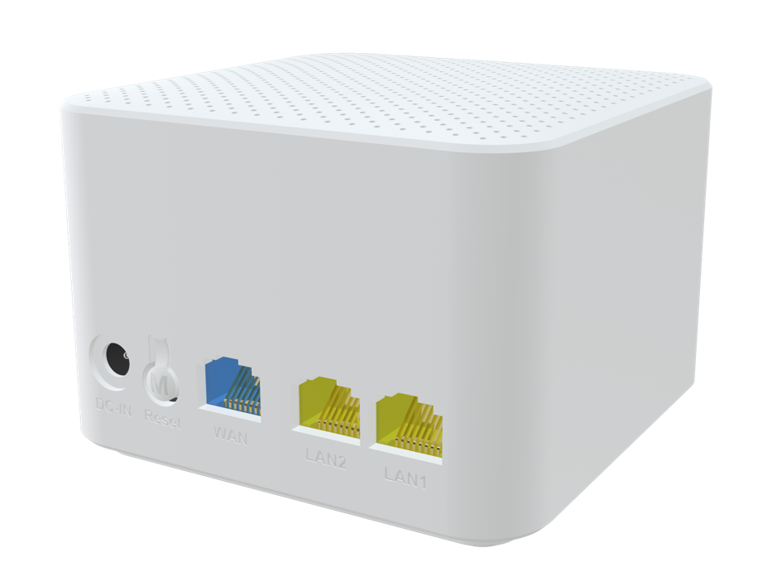

 Descriptions
AZ797M is a concurrent dual band AC1200 mesh router, which has been upgraded to the latest 802.11ac standard
technology while maintaining compatibility with IEEE 802.11b/g/n and IEEE 802.11a networks. It’s a SOHO-class
network security solution for family home, broadband communications and small SOHO.

Features
● 1x 10/100/1000BASE-T Ethernet RJ45 WAN Ports ;
● 2x 10/100/1000BASE-T Ethernet RJ45 LAN Ports ;
● Support 802.11n 2T2R speed up to 300Mbps ;
● Support 802.11ac 2T2R speed up to 867Mbps ;
● Four Antennas for good coverage;



Specifications
AZ797M Specifications
CPU | Mips (1000MHz，single core)
Chip model | RTL8197FH-VG4 +RTL8367RB+ RTL8812FR
Memory | 64Mbit(8MB)/DDR2 512Mbit（64MB）
WiFi Chip | 2.4G：SOC  5G：RTL8812FR
Interface | WAN: 1* 10/100/1000Mbps auto MDI/MDI-X RJ-45 ports  LAN: 2* 10/100/1000Mbps auto MDI/MDI-X RJ-45 ports
Buttons | Reset
LED Indicators | Power, WAN, WiFi, ETH
WiFi Rate | 2.4G:802.11b/g/n@300Mbps  5G:802.11/a/n/ac@867Mbps
Frequency Band | 2.4 GHz frequency band 40MHz and 5 GHz frequency band 80MHz
Antennas | 2.4G：2*3dBi Internal antennas  5G：2*3dBi Internal antennas
Power Supply | DC 12V 1A
Product Size | 90*90*65mm(length X width X height)
Work Environment | Working temperature: 0°C—40°C Working humidity: 5—95%
WAN Connection | Support DHCP, PPPoE and Static IP address three internet access models,  Support WAN automatic detection, MAC Clone
Wireless Function | WiFi5 basic function, Guest network,  Intelligent networking, Wireless Repeater，  Easy mesh R2
Wireless Encryption | Open system and shared key；WPA-PSK，WPA2-PSK，WPA/WPA2-PSK；AES，TKIP en-cryption；
Management Function | WEB, Telnet/CLI
System Maintenance | Device management, Configuration management, Upgrade management, Log function, Status statistics, Restart/reset
Advanced Function | Parental control, Virtual server, DDNS, VPN, IPV6, UPnP  ARP、ICMP、NAT、ALG，Firewall
Certification | Meet CE certification

