
AZ7006
BE3600 Router

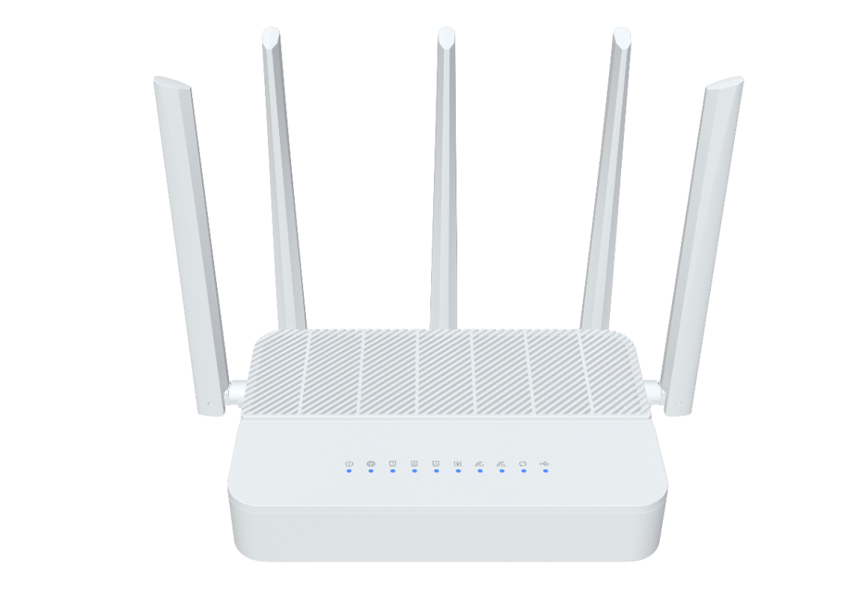
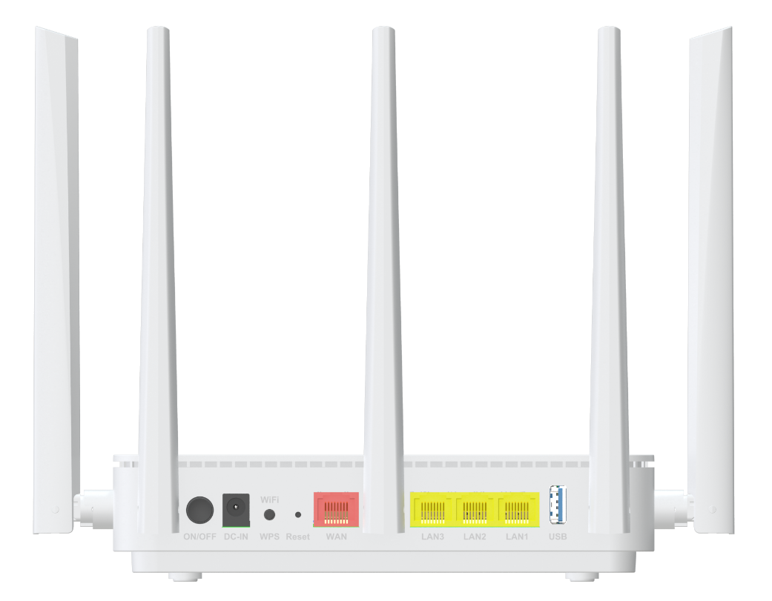

Descriptions
AZ7006 is a concurrent dual band BE3600 ROUTER, which has been upgraded to the latest 802.11be standard
technology while maintaining compatibility with IEEE 802.11b/g/n/ax and IEEE 802.11a/an/ac/ax networks. It’s a SOHO-class
network security solution for family home, broadband communications and small SOHO.

Features
● 1x 10/100/1000/2500 BASE-T Ethernet RJ45 WAN Ports ;
● 3x 10/100/1000 BASE-T Ethernet RJ45 LAN Ports ;
● Support 802.11be 2T2R speed up to 689Mbps ;
● Support 802.11be 2T2R speed up to 2882Mbps ;
● Five Antennas for good coverage ;


Specifications

AZ7006 Specifications
CPU | ARM CA53 (2GHz, Dual-core)
Chip model | MT7987BV+MT7990AN+MT7976CN+AN8855H
Memory | NAND FLASH 1Gbit(128MB)/DDR3 4Gbit（512MB）
WiFi Chip | MT7990AN+MT7976CN
WiFi eFEM | N/A (iPAiLNA)
Network Protocol | IPv4/IPv6 Dual Stack  NAT/PAT/ALG  Port mapping/DMZ/Virtual server  UPnP IGD with NAT traversal capability  Static routing/dynamic routing  Dynamic DNS relay  DHCP client/server  IGMP and MLD snooping/proxy
Interface | WAN: 1* 10/100/1000Mbps/2500Mbps auto MDI/MDI-X RJ-45 ports  LAN: 3* 10/100/1000Mbps auto MDI/MDI-X RJ-45 ports  USB3.0 *1
Buttons | WPS/WiFi ，Reset，Power on/off
LED Indicators | Power, Internet, LAN1, LAN2, LAN3, WAN, 2.4G WLAN, 5G WLAN, WPS, USB
WiFi Rate | 2.4G:802.11b/g/n/ax/be up to 689Mbps  5G:802.11/a/n/ac/ax/be up to 2882Mbps
Frequency Band | 2.4 GHz frequency band 20/40MHz  5 GHz frequency band 20/40/80/160MHz
Antennas | 2.4G：2*5dBi External antennas  5G： 3*5dBi External antennas
Power Supply | DC 12V 1.5A

Product Size | 180x120x42.2 mm (length x width x height)
Work Environment | Working temperature: 0°C—40°C  Working humidity: 5—95%
WAN Connection | Support DHCP, PPPoE and Static IP address three internet access models
Wireless Function | WiFi basic function, Guest network,  Intelligent networking, Wireless Repeater，  Easy mesh
Wireless Encryption | WPA/WPA2, WPA2, WPA3
Management Function | WEB, Telnet/CLI,TR069
System Maintenance | Device management, Configuration management, Upgrade management, Log function, Status statistics, Restart/reset
Advanced Function | Parental control, Virtual server, DDNS, VPN, IPV6, UPnP
Certification | Meet CE certification

