
AZ7005
AX3000 WiFi Router

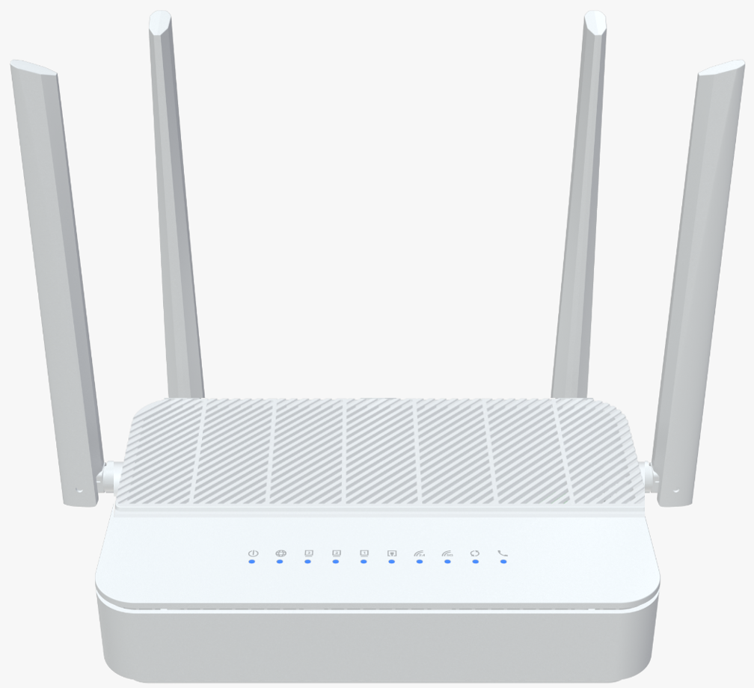
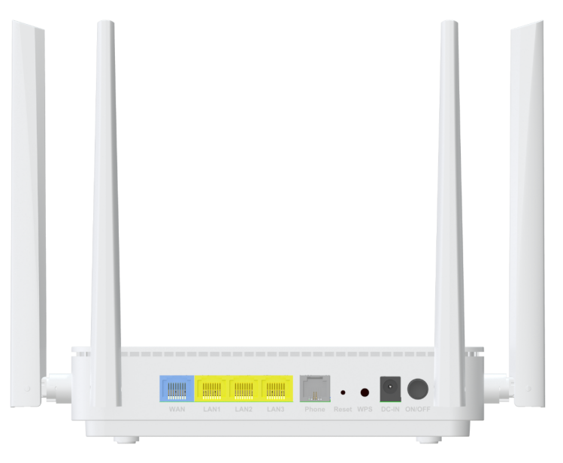
Descriptions
AZ7005 is a concurrent dual band ax3000 wireless router, which has been upgraded to the latest 802.11ax standard
technology while maintaining compatibility with IEEE 802.11b/g/n and IEEE 802.11a networks. It’s a SOHO-class
network security solution for family home, broadband communications and small SOHO.

Features
● 1x 10/100/1000BASE-T Ethernet RJ45 WAN Port;
● 3x 10/100/1000BASE-T Ethernet RJ45 LAN Ports;
● WAN port support passive POE out for ODU（option）;
● Support one VOIP port;
● Support 802.11ax 2T2R speed up to 574Mbps;
● Support 802.11ax 2T2R speed up to 2402Mbps;
● Four Antennas for good coverage;


Specifications
AZ7005 Specifications
CPU | ARM CA53 (1GHz, Dual-core)
Chip model | EN7562CT+MT7916AN+MT7976DN+Le9643
Memory | NAND FLASH 1Gbit(128MB)/DDR3 4Gbit（512MB）
WiFi Chip | 2.4G&5G: MT7916AN+MT7976DN
Interface | WAN: 1* 10/100/1000Mbps auto MDI/MDI-X RJ-45 port (passive POE out)  LAN: 3* 10/100/1000Mbps auto MDI/MDI-X RJ-45 ports  1* VOIP port
Buttons | WiFi/WPS, Reset
LED Indicators | POWER, Internet, LAN3-LAN1, WAN,2.4G,5G, WPS, FXS
WiFi Rate | 2.4G:802.11b/g/n/ax@574Mbps  5G:802.11/a/an/ac/ax@2402Mbps
Frequency Band | 2.4 GHz frequency band 40MHz and 5 GHz frequency band 160MHz
Antennas | 2*5G 5dBi External antennas  1*2.4G 5dBi External antenna  1*2.4&5G 3dBi Dual-band External antenna
Power Supply | DC 54V/1A or DC12V/1.5A (no support POE)
Product Size | 180X120X42.2 mm (length X width X height)
Work Environment | Working temperature: 0°C—40°C  Working humidity: 5—95%
WAN Connection | Support DHCP, PPPoE and Static IP address three internet access models,  Support WAN automatic detection, MAC Clone
Wireless Function | WiFi5/WiFi6 basic function, Guest network,  Intelligent networking, Wireless Repeater，  Easy mesh
Wireless Encryption | WPA/WPA2, WPA2, WPA3
Management Function | WEB, Telnet/CLI
System Maintenance | Device management, Configuration management, Upgrade management, Log function, Status statistics, Restart/reset
Advanced Function | Parental control, Virtual server, DDNS, VPN, IPV6, UPnP
Certification | Meet CE certification

