
AZ639
VDSL IAD

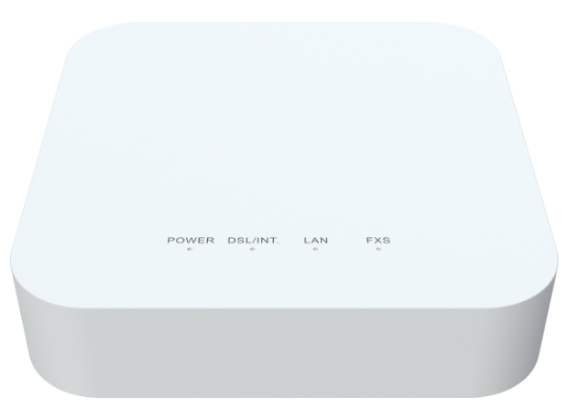
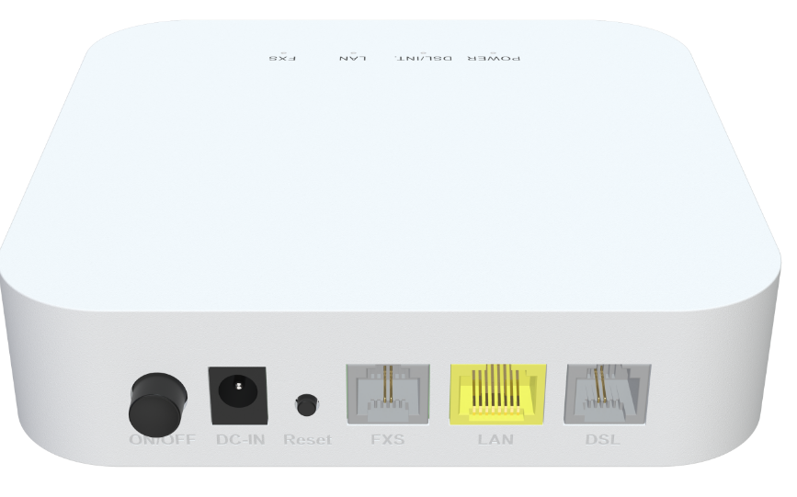

Descriptions
The AZ639 integrates VDSL + VoIP. It is a security solution for home, broadband remote office and small-scale SOHO network.

Features
● DSL WAN port with 60Mbps uplink / 350Mbps downlink link speed ;
● 1x 10/100/1000BASE-T Ethernet RJ45 Port ;
● Support one FXS port ;



Specifications

AZ639 Specifications
CPU | 900MHz Mips 1004Kc with dual-core
Chip model | EN7516GT+EN7556N+Le9643
Memory | SPI NAND FLASH 1Gbit (128MB)/DDR3 2Gbit（256MB）
DSL Driver | EN7556N
DSL Protocol Specification | G.992.1 (G.dmt), G.992.2 (G.lite), G.992.3 (ADSL2), G.992.5 (ADSL2+)  Annex A/B/I/J/M/L  ADSL physical connection ATM  AAL5  RFC 2684/1483  G.993.2 VDSL2 (Up to 35b profile)  Band plan: Annex A/B  Dual latency  UPBO/DPBO  Double-end line test(DELT)  Auto SRA  Bit Swap
Network Protocols | IPv4/IPv6 Dual Stack  TCP/UDP/ICMP  HTTP/HTTPS/TFTP/TELNET/SSH  VLAN  NAT/PAT/ALG  UPnP IGD with NAT traversal capability  RIP v1/v2  DNS Proxy/Dynamic DNS  SIP/RTP  DHCP client/server/relay  IGMP and MLD snooping/proxy

Interface | DSL: RJ-11 Port with 35b  LAN: 1*10/100/1000 auto MDI/MDI-X RJ-45 ports  VoIP: 1*RJ-11 port
Buttons | Reset, Power on/off
LED Indicators | Power, DSL/ Internet, LAN, FXS
Power Supply | DC12V 1A
Security | Stateful Packet Inspection (SPI)  Denial of Service (DoS) prevention  Multiple VPN (IPSec, PPTP,L2TP) passthrough  MAC/IP/URL filtering  Black and white list  Port mapping/DMZ/Virtual server  Remote Access Control
WAN Networking | Static IP WAN connection  DHCP client WAN connection  PPPoE WAN connection  VPN client/passthrough  Router/Bridge Mode
VOIP | G.711A/μ, G.729, and G.722 encoding/decoding  T.30/T.38/G.711 fax mode  DTMF /Emergency calls (with the SIP protocol)
Wireless | Basic/Advanced Settings  WEP/WPA1/WPA2/WPS  MESH  Band Steering  Multiple SSID  WMM  Channel scan  WDS  ACL list
Management | TR-069 remote management  Web GUI management  Local built-in diagnostic function  Logs and statistics  Remote upgrade by HTTP  Saving/Restoring configuration to/from file  SNTP and time zone  Multi-language
Product Size | 130X130X36.5mm (length x width x height)
Work Environment | Working temperature: 0°C—40°C  Working humidity: 5—95%
Certification | Meet CE certification

