
AZ638
AX3000 VDSL IAD

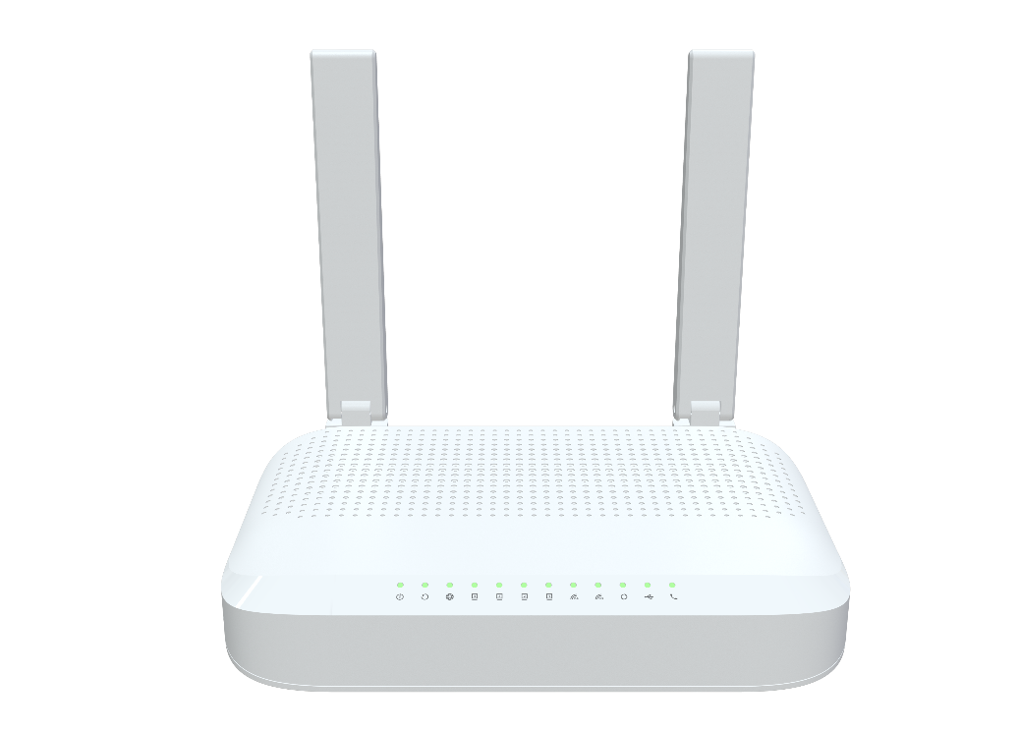
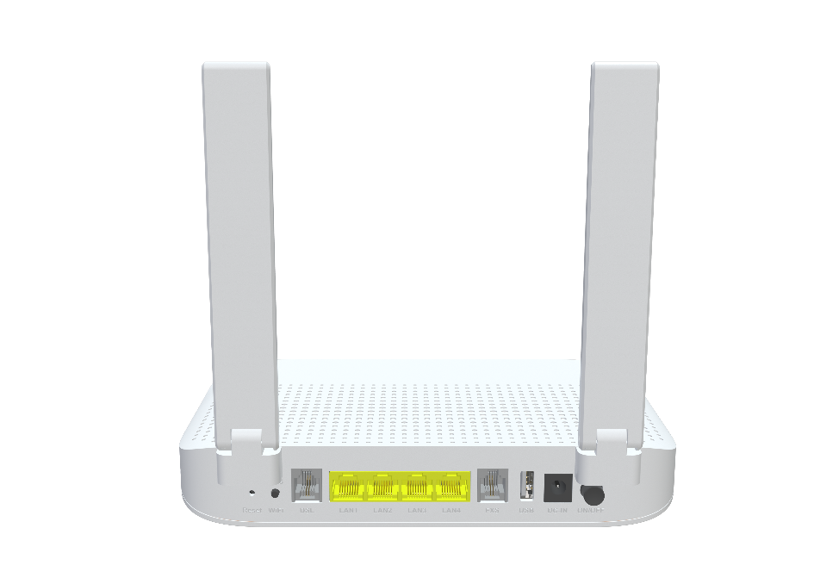

 Descriptions
The AZ638 is a Wi-Fi 6 Gigabit dual band wireless IAD, which is upgraded to the 802.11ax technical standard and integrates VDSL/VoIP/wireless AP. It is a security solution for home, broadband remote office and small-scale SOHO network.

Features
● DSL WAN port with 50Mbps uplink / 350Mbps downlink link speed ;
● 4x 10/100/1000BASE-T Ethernet RJ45 Ports ;
● Support 802.11n/ax 2T2R speed up to 574Mbps ;
● Support 802.11ac/ax 3T3R speed up to 2402Mbps ;
● Support one FXS ports ;
● Support one USB2.0 port ;


Specifications

AZ638 Specifications
CPU | 1GHz ARM CA53 dual-core 256K L2 cache
Chip model | EN7562CT+MT7916AN+MT7976DN+EN7556N+EN7517BU+Le9643
Memory | NAND FLASH 1Gbit(128MB)/DDR3 2Gbit（512MB）
Wi-Fi Chip | 2.4G&5G: MT7916AN+MT7976DN
DSL Driver | EN7556N
DSL Protocol Specification | G.992.1 (G.dmt), G.992.2 (G.lite), G.992.3 (ADSL2), G.992.5 (ADSL2+)  Annex A/B/I/J/M/L  ADSL physical connection ATM  AAL5  RFC 2684/1483  G.993.2 VDSL2 (Up to 35b profile)  Band plan: Annex A/B  Dual latency  UPBO/DPBO  Double-end line test (DELT)  Auto SRA  Bit Swap
Network Protocols | IPv4/IPv6 Dual Stack  TCP/UDP/ICMP  HTTP/HTTPS/FTP/TFTP/TELNET/SSH  VLAN  NAT/PAT/ALG  UPnP IGD with NAT traversal capability  RIP v1/v2  DNS Proxy/Dynamic DNS  SIP/RTP  DHCP client/server/relay  IGMP and MLD snooping/proxy

Interface | WAN: RJ-11 Port with 35b  LAN: 4*10/100/1000 auto MDI/MDI-X RJ-45 ports  VoIP: RJ-11 port  USB: 1*USB2.0
Buttons | WPS/Reset/Wi-Fi/Power on/off
LED Indicators | Power, DSL, Internet, LAN4-LAN1, 2.4GWIFI, 5GWIFI, WPS, USB, FXS
Wi-Fi Rate | 2.4G: 802.11b/g/n/ax@574Mbps  5G: 802.11/a/n/ac/ax@2402Mbps
Frequency Band | 2.4 GHz frequency band 40MHz and 5.8 GHz frequency band 160MHz
Antennas | 2*3dBi External dual-band omni antennas  1*3dBi built-in 5G omni antenna
Power Supply | DC12V 2A（Without USB 1.5A）
Security | Stateful Packet Inspection (SPI)  Denial of Service (DoS) prevention  Multiple VPN (IPSec, PPTP, L2TP) passthrough  MAC/IP/URL filtering  Black and white list  Port mapping/DMZ/Virtual server  Remote Access Control
WAN Networking | Static IP WAN connection  DHCP client WAN connection  PPPoE WAN connection  3G/4G dongle  VPN client/passthrough  Router/Bridge Mode
VOIP | G.711A/μ, G.729, and G.722 encoding/decoding  T.30/T.38/G.711 fax mode  DTMF /Emergency calls (with the SIP protocol)
Wireless | Basic/Advanced Settings  WEP/WPA1/WPA2/WPA3/WPS  MESH  Band Steering  Multiple SSID  WMM  Channel scan  WDS  ACL list
Management | TR-069 remote management  Web GUI management  Local built-in diagnostic function  Logs and statistics  Remote upgrade by HTTP  Saving/Restoring configuration to/from file  SNTP and time zone  Multi-language
Product Size | 211.5X151.9X38.5mm (length x width x height)
Work Environment | Working temperature: 0°C—40°C  Working humidity: 5—95%
Certification | Meet CE certification

