
AZ554G
5GE BE3600 GPON HGU

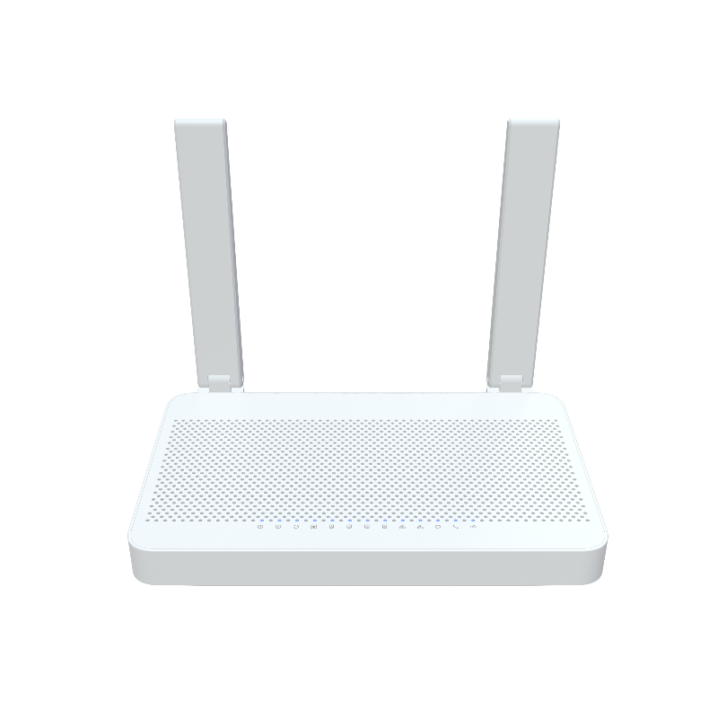
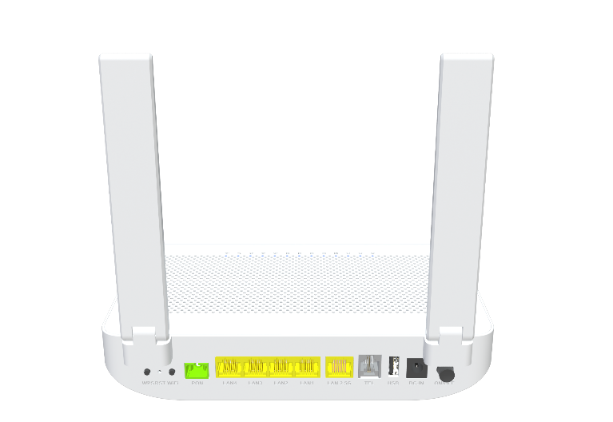

 Descriptions
AZ554G GPON ONT is a new terminal level GPON ONT, which is a variety of FTTB \ FTTH \ FTTO access ONT
manufactured and supplied by AZROAD for carrier-grade FTTH network applications. It can support pure data,
WIFI and many other services accessing type. AZ554G ONT supports standard OMCI, which provides up to
1.25Gbps uplink and 2.5Gbps downlink high-speed transfer rate. AZ554G supports 802.11be dual band Wi-Fi
speed up to 3.6Gbps.

Features
● GPON WAN port with 1.244Gbps uplink / 2.488Gbps downlink link speed;
● 1x 10/100/1000/2500BASE-T Ethernet RJ45 Ports
● 4x 10/100/1000BASE-T Ethernet RJ45 Ports;
● Support 802.11be 2T2R speed up to 689Mbps;
● Support 802.11be 2T3R speed up to 2882Mbps;
● Support Voip;
● Support USB2.0


Specifications

AZ554G Specifications
CPU | 1.2GHz ARM CA53 dual-core
Chip model | AN7553CT+ MT7990AN+MT7976CN+ AN8801SBN+ EN7571N+Le9643
Memory | NAND FLASH 2Gbit(256MB)/ 512MB DDR3 SDRAM
Wi-Fi Chip | MT7990AN+MT7976CN
Bob Driver | EN7571N
GPON Protocol Specification | Comply ITU-T G.984 GPON standard:  G.984.1 general characteristics  G.984.2 physical Media Dependent (PMD) layer specifications  G.984.3 transmission convergence layer specifications  G.984.4 ONT management and control interface specification  Support DS/US transmission rate to 2.488 Gbps/1.244 Gbps  Wavelength: 1490 nm downstream & 1310 nm upstream  Comply with class B+ type PMD  Physical distance reach to 20 km  Support Dynamic Bandwidth Allocation (DBA)  GPON Encapsulation Method (GEM) supports Ethernet packet  Supports GEM header removal/insertion and data extraction/segmentation (GEM SAR)  Configurable AES DS and FEC DS/US  Support up to 8 T-CONs each with priority queues (US)
Network Protocol Specifications | 802.3 10/100/1000 Base T Ethernet  ANSI/IEEE 802.3 NWay auto-negotiation  802.1Q VLAN tagging/un-tagging  Support flexible traffic classification  Support VLAN staking  Support VLAN Intelligent Bridging and Cross Connect mode

Interface | WAN: One Giga optical interface (APC or UPC)  LAN: 1*10/100/1000Mbps/2500Mbps+4*10/100/1000 auto MDI/MDI-X RJ-45 ports  Voip: 1*RJ-11 port  USB: 1*USB2.0
LED Indicators | Power, INT, PON/LOS, 2.5G LAN. LAN4-1, 2.4G WLAN, 5G WLAN, WPS, TEL, USB
Wi-Fi Rate | 2.4G: 802.11be with 689Mbps  5G: 802.11be with 2882Mbps
Frequency Band | 2.4 GHz frequency band 40MHz and 5.8 GHz frequency band 160MHz
Buttons | WPS/WLAN/Reset
Antennas | 1*5G 3dBi Internal antennas  2*2.4G&5G 4dBi External antennas
Power Supply | DC12V 1.5A
Product Size | 215X130X43 mm (length X width X height)
Work Environment | Working temperature: 0°C—40°C  Working humidity: 5—95%
Security | WPA/WPA2/WPA3, 64/128bit WEP data encryption  Firewall, Dos Protection, ssl connection
WAN Networking | Static IP WAN connection  DHCP client WAN connection  PPPoE WAN connection
VOIP | G.711A/μ, G.729, and G.722 encoding/decoding  T.30/T.38/G.711 fax mode  DTMF /Emergency calls (with the SIP protocol)
Management | Standard OMCI (G.984.4)  Web GUI (HTTP/HTTPS)  Firmware upgrade via TFTP/HTTP/TR069/OMCI  Telnet, Web, SSH  CLI command via telnet/console  Configuration backup/restore  TR069
Certification | Meet CE certification

