
AZ546G-S
4GE AX3000 GPON HGU

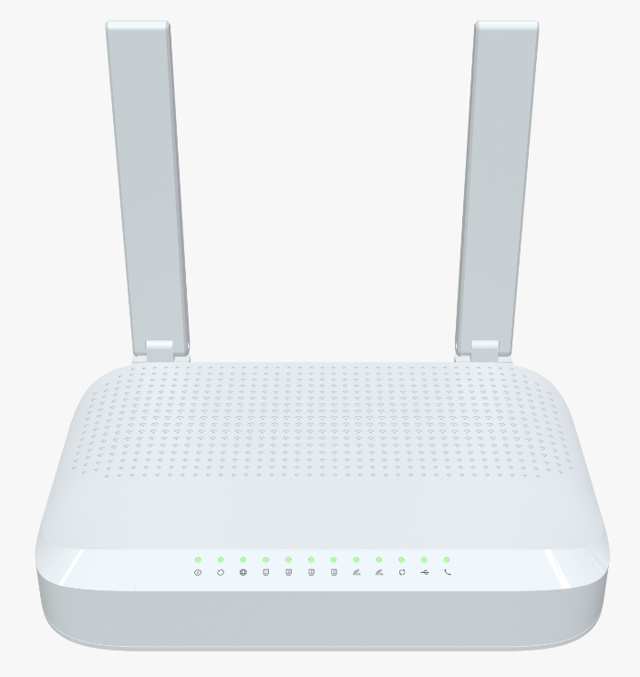
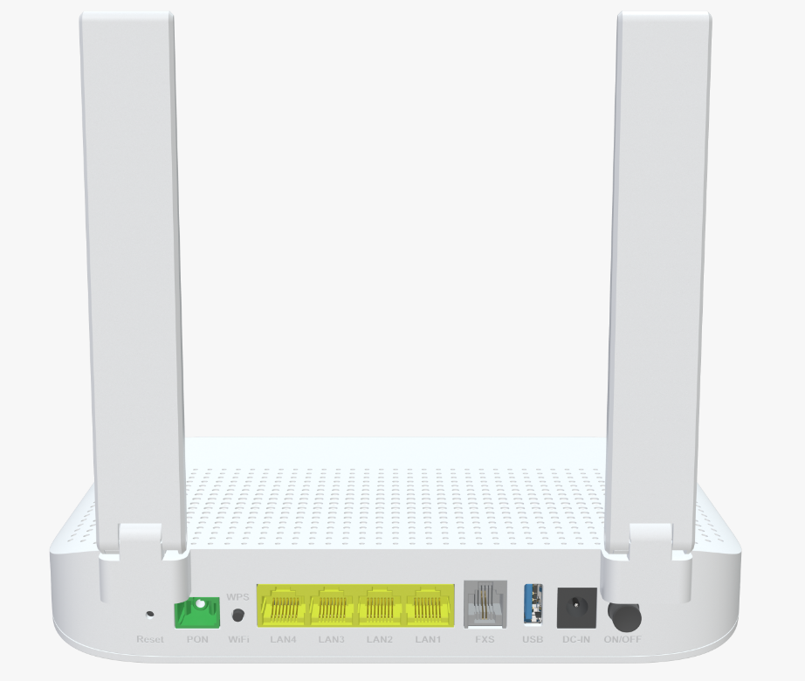
 Descriptions
AZ546G-S GPON ONT is a new terminal level GPON ONT, which is a variety of FTTB \ FTTH \ FTTO access ONT
manufactured and supplied by AZROAD for carrier-grade FTTH network applications. It can support pure data,
WIFI and many other services accessing type. AZ546G-S ONT supports standard OMCI, which provides up to
1.25Gbps uplink and 2.5Gbps downlink high-speed transfer rate. AZ546G-S supports 802.11ax dual band Wi-Fi
speed up to 2.4Gbps.

Features
● GPON WAN port with 1.244Gbps uplink / 2.488Gbps downlink link speed;
● 4x 10/100/1000BASE-T Ethernet RJ45 Ports;
● Support 802.11n/ax 2T2R speed up to 574Mbps;
● Support 802.11ac/ax 2T3R speed up to 2400Mbps;
● Support Voip;
● Support USB2.0



Specifications

AZ546G-S Specifications
CPU | 1.0GHz ARM CA53 dual-core CPU,256K L2 cache
Chip model | EN7529CU+MT7916AN+MT7976DN+EN7571N+Le9643
Memory | NAND FLASH 1Gbit(128MB)/ Integrate 512MB DDR3 SDRAM
WiFi Chip | 2.4G&5G: MT7916AN+MT7976DN
Bob Driver | EN7571N
GPON Protocol Specification | Comply ITU-T G.984 GPON standard:  G.984.1 general characteristics  G.984.2 physical Media Dependent (PMD) layer specifications  G.984.3 transmission convergence layer specifications  G.984.4 ONT management and control interface specification  Support DS/US transmission rate to 2.488 Gbps/1.244 Gbps  Wavelength: 1490 nm downstream & 1310 nm upstream  Comply with class B+ type PMD  Physical distance reach to 20 km  Support Dynamic Bandwidth Allocation (DBA)  GPON Encapsulation Method (GEM) supports Ethernet packet  Supports GEM header removal/insertion and data extraction/segmentation (GEM SAR)  Configurable AES DS and FEC DS/US  Support up to 8 T-CONs each with priority queues (US)
Network Protocol Specifications | 802.3 10/100/1000 Base T Ethernet  ANSI/IEEE 802.3 NWay auto-negotiation  802.1Q VLAN tagging/un-tagging  Support flexible traffic classification  Support VLAN staking  Support VLAN Intelligent Bridging and Cross Connect mode

Interface | WAN: One Giga optical interface (APC or UPC)  LAN: 4*10/100/1000 auto MDI/MDI-X RJ-45 ports  Voip: 1*RJ-11 port  USB: 1* USB2.0
LED Indicators | Power, PON/LOS, INT, LAN4-1, 2.4G WLAN, 5G WLAN , WPS, USB, TEL
WiFi Rate | 2.4G: 802.11n/ax with 574Mbps  5G: 802.11ac/ax with 2400Mbps
Frequency Band | 2.4 GHz frequency band 40MHz and 5.8 GHz frequency band 160MHz
Buttons | WPS/WLAN/Reset
Antennas | 1*5G 5dBi Internal antennas  2*2.4G&5G 4dBi External antennas
Power Supply | DC12V 1.5A
Product Size | 211.5X151.9X38.5 mm (length X width X height)
Work Environment | Working temperature: 0°C—40°C  Working humidity: 5—95%
Security | WPA/WPA2/WPA3, 64/128bit WEP data encryption  Firewall, Dos Protection, ssl connection
WAN Networking | Static IP WAN connection  DHCP client WAN connection  PPPoE WAN connection
VOIP | G.711A/μ, G.729, and G.722 encoding/decoding  T.30/T.38/G.711 fax mode  DTMF /Emergency calls (with the SIP protocol)
Management | Standard OMCI (G.984.4)  Web GUI (HTTP/HTTPS)  Firmware upgrade via TFTP/HTTP/TR069/OMCI  Telnet, Web, SSH  CLI command via telnet/console  Configuration backup/restore  TR069
Certification | Meet CE certification

