
AZ549G
10GE XGS-PON SFU

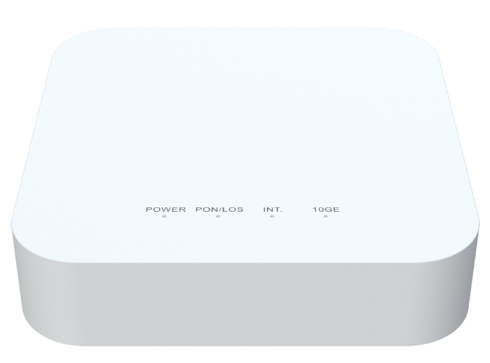
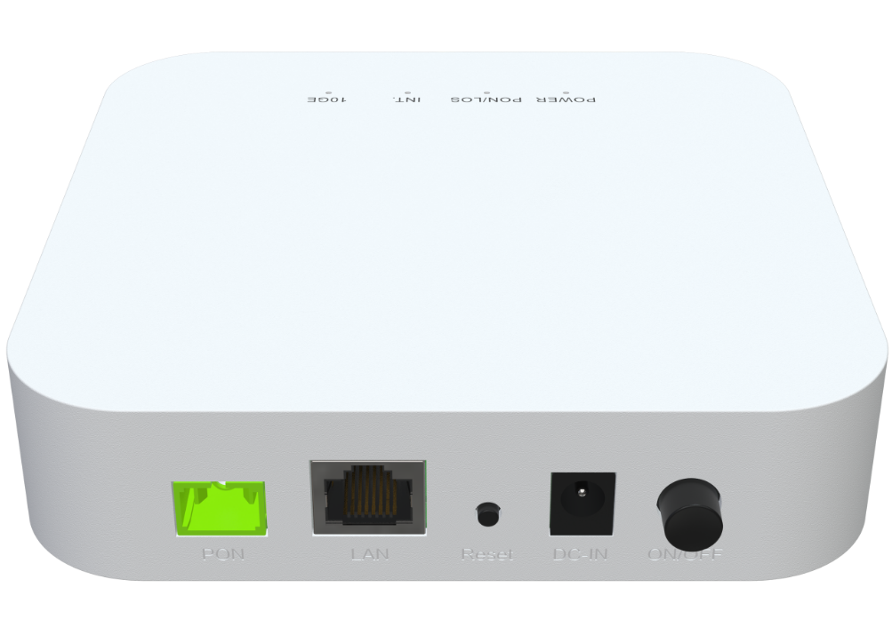

Descriptions
The AZ549G is a 10GE XGSPON fiber optic modem, which is designed to meet the FTTH ultra-wide band access requirements of home and SOHO users. It supports NAT / firewall and other functions. It is based on stable and mature GPON technology with high cost-performance and layer 2 Ethernet switch technology. It is reliable and easy to maintain, guarantees QoS, and fully conforms to ITU-T g.9807 XGSPON standard.

Features
● XGS-PON WAN port with 10Gbps uplink / 10Gbps downlink link speed;
● 1x 10/100/1000/2.5G/5G/10G BASE-T Ethernet RJ45 Ports;



Specifications

AZ549G Specifications
CPU | Dual-Core ARM Cortex-A55 at 1.0GHz
Chip model | RTL9615C
Memory | NAND FLASH 1Gbit(128MB)/DDR4 4Gbit（512MB）
Bob Driver | GN28L98
PON Protocol Specification | The XGS-PON(10G/10G)ITU-T G.9807.1 MAC supports the following features  Supports data rate of:  ~10Gbps(9953 Mbps)downstream.  ~10Gbps(9953Mbps) upstream. Up to 256 GEM port-IDs.  Up to 40 AlloclDs.  Ranging and activation process support.  Downstream characteristics:  -Downstream AES-128 encryption and key exchange process.  -Downstream FECRS(248216).  -Dedicated independent queues for PLOAM and CPU packets.  Upstream characteristics:  -Upstream AES-128 encryption and key exchange process.  -Upstream FECRS(248216.)  -Normal queues for PLOAM and CPU.  Support ToD synchronization perITU-TG.9807.1.  Support ONU power saving operation perITU-TG.9807.1.
Network Protocol Specifications | ANSI/IEEE 802.3 NWay auto-negotiation  802.1D bridging  VLAN Translation  IP ToS/DSCP to 802.1p mapping  Class of Service based on UNI, VLAN-ID, 802.1p bit, and combination  Marking/remarking of 802.1p  IGMP v2/v3 snooping and IGMP snooping with proxy report  Broadcast/Multicast rate limiting

802.1Q VLAN tagging/un-tagging
Support flexible traffic classification
Support VLAN Intelligent Bridging and Cross Connect mode
Interface | WAN: 1*10G optical interface (APC)  LAN: 1*10/100/1000/2.5G/5G/10G auto MDI/MDI-X RJ-45 ports
LED Indicators | Power, PON, LOS, INTERNET, 10G LAN
Power Supply | DC12V 1.0A
Security | Firewall, Dos Protection
WAN Networking | Static IP WAN connection  DHCP client WAN connection  PPPoE WAN connection
Management | Standard OMCI (G.988)  Web GUI (HTTP/HTTPS)  Firmware upgrade via FTP/TFTP/HTTP  Telnet, Web, SSH  CLI command via telnet/console  Two-level administration privilege for web configuration  Configuration backup/restore  TR069
Product Size | 130X130X36.5mm(length X width X height)
Work Environment | Working temperature: -0°C—40°C  Working humidity: 5—95%

Applications
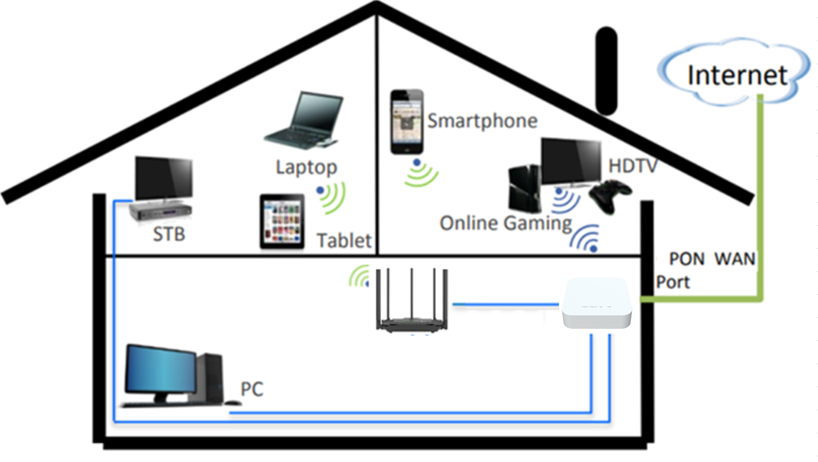

Contact us
AZROAD TECHNOLOGY COMPANY LTD.
Mail to: sales@azroad.com
URL: http://www.azroad.com/en
Specifications are subject to change without notice.
Copyright © AZROAD. All rights reserved.


