

AZ547G

4GE+10GE XGS-PON SFU

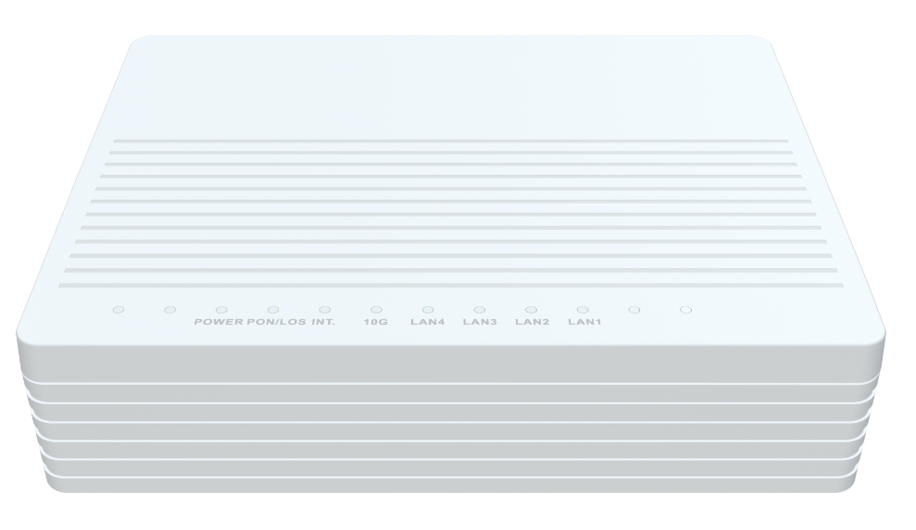

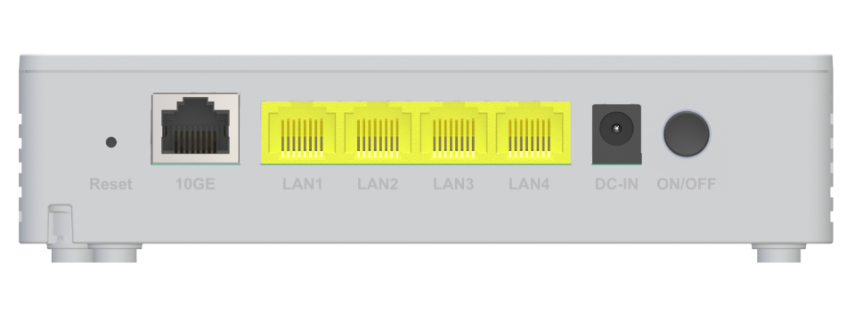

未标题-3 **Descriptions**

The AZ547G is a 10GE XGSPON fiber optic modem, which is designed to meet the FTTH ultra-wide band access requirements of home and SOHO users. It supports NAT / firewall and other functions. It is based on stable and mature GPON technology with high cost-performance and layer 2 Ethernet switch technology. It is reliable and easy to maintain, guarantees QoS, and fully conforms to ITU-T g.9807 XGSPON standard.

未标题-3 **Features**

● XGS-PON WAN port with 10Gbps uplink / 10Gbps downlink link speed;

● 1x 10/100/1000/2.5G/5G/10G BASE-T Ethernet RJ45 Ports;

● 4x 10/100/1000BASE-T Ethernet RJ45 Ports ;





未标题-3 **Specifications**

|  |  |
| --- | --- |
| AZ547G Specifications | |
| CPU | Dual-Core ARM Cortex-A55 at 1.0GHz |
| Chip model | RTL9615C |
| Memory | NAND FLASH 1Gbit(128MB)/DDR4 4Gbit（512MB） |
| Bob Driver | GN28L98 |
| PON Protocol Specification | The XGS-PON(10G/10G)ITU-T G.9807.1 MAC supports the following features  Supports data rate of:  ~10Gbps(9953 Mbps)downstream.  ~10Gbps(9953Mbps) upstream. Up to 256 GEM port-IDs.  Up to 40 AlloclDs.  Ranging and activation process support.  Downstream characteristics:  -Downstream AES-128 encryption and key exchange process.  -Downstream FECRS(248216).  -Dedicated independent queues for PLOAM and CPU packets.  Upstream characteristics:  -Upstream AES-128 encryption and key exchange process.  -Upstream FECRS(248216.)  -Normal queues for PLOAM and CPU.  Support ToD synchronization perITU-TG.9807.1.  Support ONU power saving operation perITU-TG.9807.1. |
| Network Protocol Specifications | ANSI/IEEE 802.3 NWay auto-negotiation  802.1D bridging  VLAN Translation  IP ToS/DSCP to 802.1p mapping  Class of Service based on UNI, VLAN-ID, 802.1p bit, and combination  Marking/remarking of 802.1p  IGMP v2/v3 snooping and IGMP snooping with proxy report  Broadcast/Multicast rate limiting |





|  |  |
| --- | --- |
|  | 802.1Q VLAN tagging/un-tagging  Support flexible traffic classification  Support VLAN Intelligent Bridging and Cross Connect mode |
| Interface | WAN: 1*10G optical interface (APC)  LAN: 1*10/100/1000/2.5G/5G/10G auto MDI/MDI-X RJ-45 ports  LAN：4*10/100/1000M auto MDI/MDI-X RJ-45 ports |
| LED Indicators | Power, PON/ LOS, INTERNET, 10G LAN, LAN4-LAN1 |
| Power Supply | DC12V 1.0A |
| Security | Firewall, Dos Protection |
| WAN Networking | Static IP WAN connection  DHCP client WAN connection  PPPoE WAN connection |
| Management | Standard OMCI (G.988)  Web GUI (HTTP/HTTPS)  Firmware upgrade via FTP/TFTP/HTTP  Telnet, Web, SSH  CLI command via telnet/console  Two-level administration privilege for web configuration  Configuration backup/restore  TR069 |
| Product Size | 150X115X36mm(length X width X height) |
| Work Environment | Working temperature: 0°C—40°C Working humidity: 5—95% |





未标题-3 **Applications**

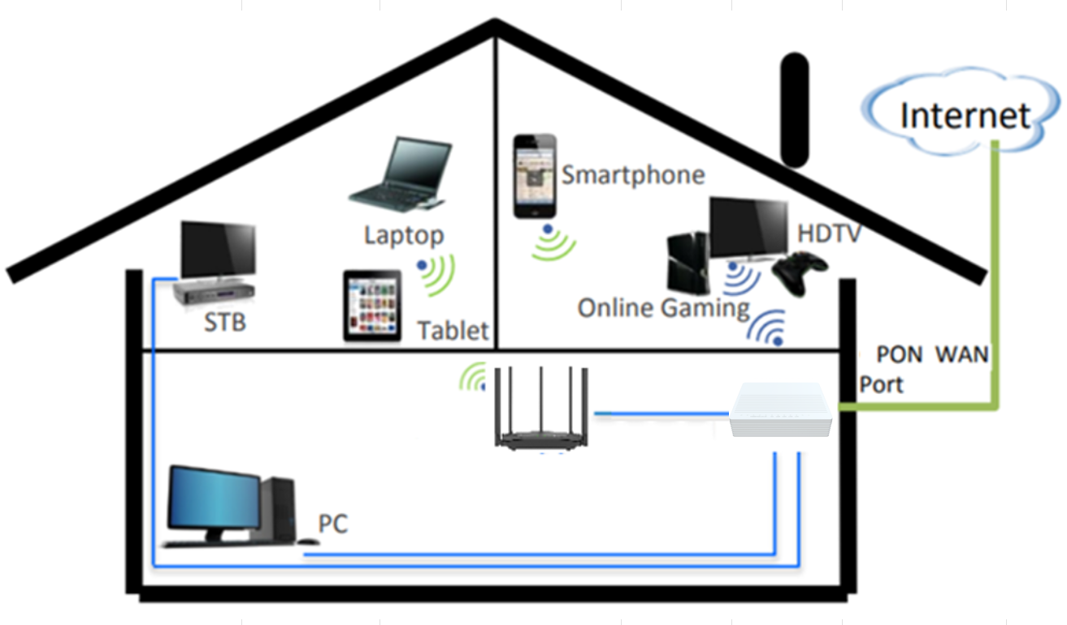

## 未标题-3 **Contact us**

***AZROAD TECHNOLOGY COMPANY LTD.***

Mail to: sales@azroad.com

URL: http://www.azroad.com/en

Specifications are subject to change without notice.

Copyright © AZROAD. All rights reserved.

未标题-1

